Given that:



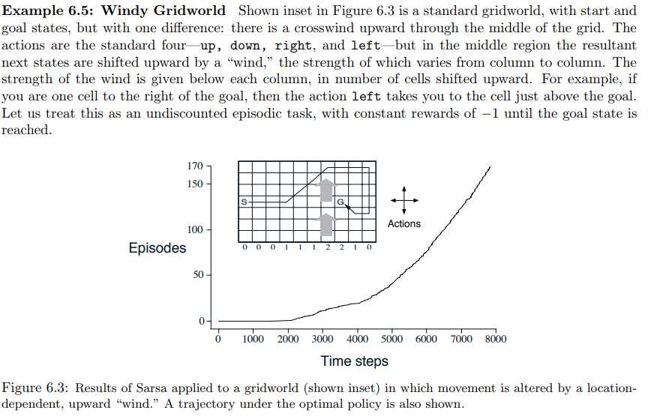

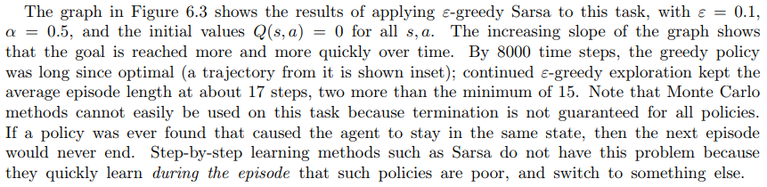

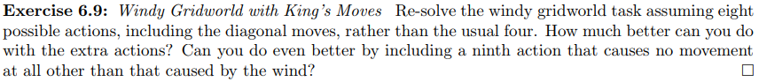

This exercise is from: <http://incompleteideas.net/book/the-book.html>

* You need to indicate your discount rate and learning rate
* You need to show a few examples of the values of Q’s as they change
* You need to show the final optimum solution